Everything Enterprise Lists

Enterprise allows users to create lists of books, and for those with a library card, the ability to log in and save those lists permanently.

To add an item to a list from the list of search results:
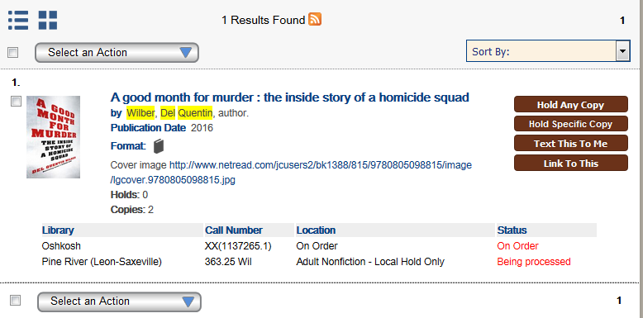

Check the box next to the item (you can also select multiple items from the search results to add to a list at once), then go up to the “Select an Action” dropdown and drop to “Add to My Lists”.

You can also add an item to a list from the item’s detailed information; after clicking on the title of an item in the search results, the same “Select an Action” dropdown appears to the right of the item’s information:
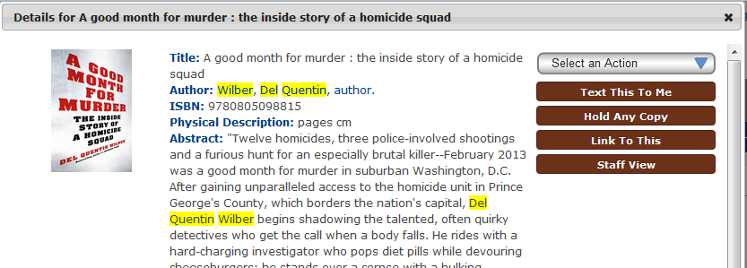

Clicking on “Add to My Lists” from either the search results or the item’s details, if you haven’t logged in, this box pops up:
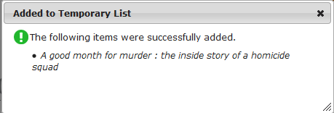
The item is saved to a temporary list. You can find this temporary list by going up to the top menu:

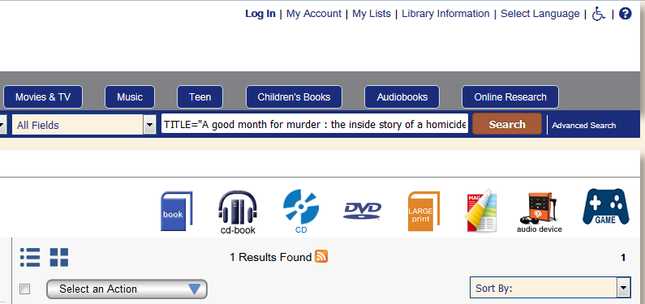

Click on “My Lists”, after “My Account” (indicated with the red box). This screen appears:

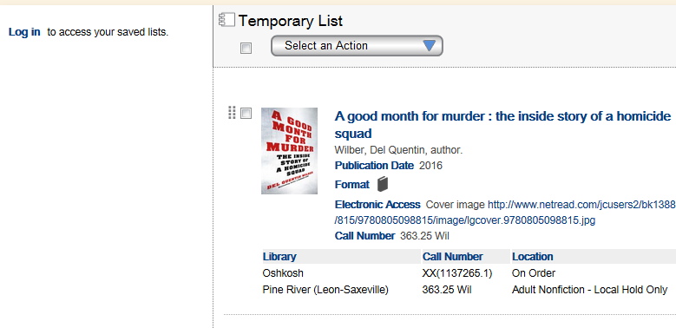

From here, you can select items, and then go to the “Select an Action” dropdown:
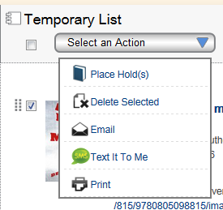

You can place a hold on the items, remove them from the list, email the list of items to yourself, text the list of the items, or print the list of the items.

Or, if you want to keep this list, you can log in and save the list:
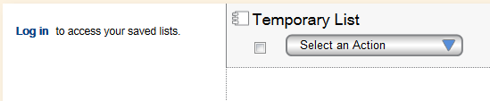
Click on “Log in”. This box pops up:
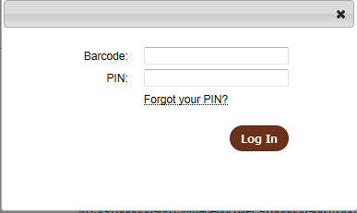
Enter your barcode and PIN. Press “Log in” or hit the Enter button.
When logged in, the page shows saved lists to the side:

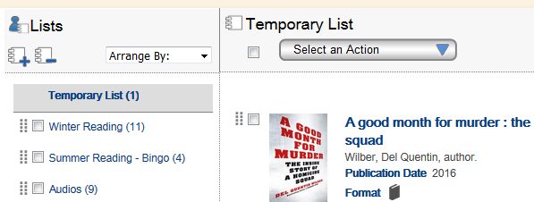

Now when you select items, there are more options in the “Select An Action” dropdown:
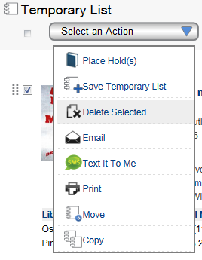

Click “Save Temporary List” to save the list as its own new list. This popup appears:
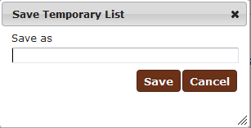
Enter a name for the list and hit ‘Save’.

Or, you can Move the items onto an existing list, or Copy them to an existing list
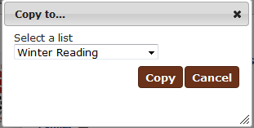
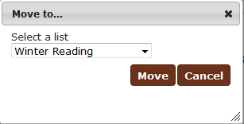
Moving items removes them from the list they are currently on. Copying items puts them on an additional list as well was the one they are currently on.

You can also move an item to another list by clicking on the dashed bar to the left of the checkbox and dragging the item to the list you desire.

If you are already logged in and select an item to add to your lists, you can directly add the item to a specific list, instead of the Temporary List.
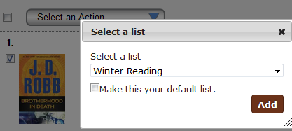

If you want, you can choose a list as your default list so that you are not prompted to choose a list to add the item to.

Go into “My Account” and select the “Personal Information” tab:
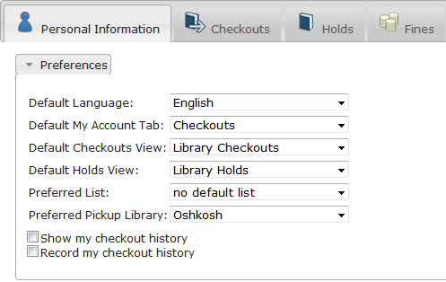
Use the dropdown box to select one of your previously created lists.

With a default list selected, when you check the box next to an item and select “Add to My List” from the “Select An Action” dropdown, this box appears:
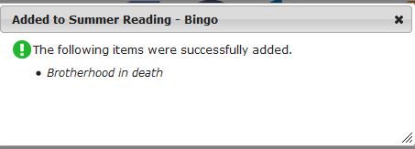
And the item is automatically added to the list set as default (In this case, the Summer Reading – Bingo) list.

If you ever want to change your default list, or to set it back to No List so that you are always prompted to choose which list to save the item to, you can do that through the same “Personal Information” tab in My Account, and setting ‘no default list’ as your Preferred (Default) list.

